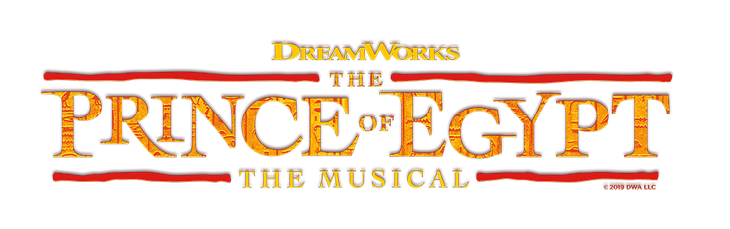

Song List by Character

Yocheved
#1 – Deliver Us
#8 – All I Ever Wanted
#14 – Act I Finale
#24A – Act II Finale
#24B – Act II Finale

Young Miriam
#1 – Deliver Us

Queen Tuya
#1 – Deliver Us
#8 – All I Ever Wanted
#14 – Act I Finale
#19 – The Plagues
#24B – Act II Finale

Moses
#2 – Faster
#4 – His Son and Heir
#5 – Footprints on the Sand
#7B – Dance to the Day (Reprise)
#8 – All I Ever Wanted
#9 – Make It Right
# 10 – Moses in the Desert
#12 – Faster (Reprise)
#13 – Never in A Million Years
#14 – Act I Finale
#17 – Always on Your Side
#18 – Simcha!
#18A – Simcha! (Playoff)
#19 – The Plagues
#21 – For the Rest of My Life
#23 – When You Believe
#24 – Act II Finale (Part 1)
#24 A – Act II Finale (Part 2)
#24B – Act II Finale (Part 3)

Ramses
#2 – Faster
#3A – One Weak Link (Reprise)
#4 – His Son and Heir
#9 – Make It Right
#12 – Faster (Reprise)
#14 – Act I Finale
#17 – Always on Your Side
#19 – The Plagues
#24A – Act II Finale (Part 2)
#24B – Act II Finale (Part 3)

Hotep
#2 – Faster
#8A – The Laws of the Gods
#14 – Act I Finale
#16 – The Naming Ceremony
#18A – Simcha! (Playoff)
#19 – The Plagues
#24A – Act II Finale (Part 2)
#24B – Act II Finale (Part 3)

Pharaoh Seti
#3 – One Weak Link
#8 – All I Ever Wanted
#24B – Act II Finale (Part 3)

Nefertari
#14 – Act I Finale
#19 – The Plagues
#22 – Heartless
#24B – Act II Finale (Part 3)

Tzipporah
#7 Dance to the Day
#7B – Dance to the Day (Reprise)
#13 – Never In a Million Years
#14 – Act I Finale
#15- Through Heaven’s Eyes
#18 – Simcha!
#23 – When You Believe
#24 – Act II Finale (Part 1)
#24A – Act II Finale (Part 2)
#24B – Act II Finale (Part 3)
Miriam
#8 – All I Ever Wanted
#18 – Simcha!
#19 – The Plagues
#23 – When You Believe
#24A – Act II Finale (Part 2)
#24B – Act II Finale (Part 3)

Aaron
#18 – Simcha
#18A – Simcha (Playoff)
#18B – Deliver Us (Reprise)
#19 – The Plagues
#24A – Act II Finale (Part 2)
#24B – Act II Finale (Part 3)

Jethro
#11 – Through Heaven’s Eyes

-----------------------------------------------------------------------------------------------------------------------------------------
Ensemble (Hebrew slaves/Egyptian Court/Priests/Midianites

#1 – Deliver Us
#2 – Faster
#4 – His Son and Heir
#6 – Seti’s Return
#7A – Tzipporah Escapes
#8A – The Laws of the Gods
#10 – Moses in the Desert
#11 – Through Heaven’s Eyes
#14 – Act I Finale
#16 – The Naming Ceremony
#18 – Simcha!
#18A – Simcha! (Playoff)
#18B – Deliver Us (Reprise)
#19 – The Plagues
#20 – They Will Be Free
#23 – When You Believe
#24A – Act II Finale (Part 2)
#24B – Act II Finale (Part 3)

