Class Act Productions 2024-2025 Season
Class Act Shoe/Undergarment Requirements

Please read the following shoe & undergarment requirements below for all cast members. Please have all required items by the COSTUME PARADE - August 30th, and earlier if possible. Parents of minors are responsible for providing the following items for their child by the costume parade as well. There are examples of the requested items at the bottom of this document. If you have any questions, please contact Amy Nash (346)808-8470 as soon as possible.

Undergarments - females
- All females should wear nude leotards with clear straps and nude bootie shorts (found at Amazon, Academy, Jazz Rags, Wal-Mart, etc.) These items should be worn throughout each dress rehearsal and performance.
- All females need to wear nude footless tights. You might consider purchasing two pairs to be prepared for the inevitable run. Jazz Rags is close to the studio, has a huge selection and has “frequent buyer” cards. If you wear tights and a leotard, it is recommended that tights are worn over the leotard. Trust me on this!
- No visible bra straps or camisole/leotard straps when wearing costumes.
- Please note, many cast members will have multiple quick changes during the run of the show, you may be changing with many people around so prepare accordingly.
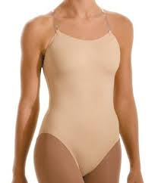 | 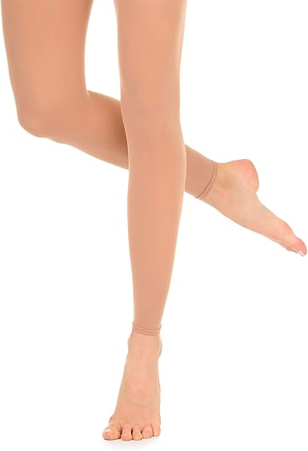 | 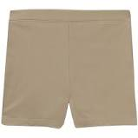

Undergarments – males
- All males should wear a white, snug-fitting, undershirt shirt and snug-fitting, light underwear, or tight-fitting bike shorts (no basketball shorts).
- Have at least one pair of long black socks, should be long enough that when on stage, the audience cannot see the skin at ankles. These should be worn with slacks or jeans.
 |  | 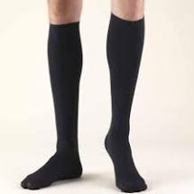

Scene/Character Specific Items:

Wives/Brothers/Pharaoh's Court:
All of these roles will wear either women’s strappy sandals or men’s strappy sandals that are comfortable to dance in. These links are examples - you may already have or find something similar. Also, if you are unable to purchase these, please send me a text, or band communication with your shoe size and we will order them for you.

COSTUME AND WARDROBE FAQs

- CAN I TAKE MY COSTUME HOME?
All costume items REMAIN at Class Act Productions for the entirety of the run. Please do not remove or use for personal use. All items loaned to you by Class Act must be returned to Class Act or you will be responsible for the cost. You may take your own personal items home after the run. We encourage you to clearly LABEL your own items with your name.
- MY COSTUME NEEDS MENDING OR CLEANING CAN I TAKE IT HOME?
If your costume needs repair or cleaning we can handle it for you. We will launder or clean costumes regularly to keep you feeling your best!
- WHY DO I NEED TO WEAR THESE UNDERGARMENTS?
This is an all ages cast with LOTS of costume changes! Please wear your undergarments so that everyone can feel comfortable in the changing spaces. We appreciate your cooperation with this!
- I HAVE A SPECIFIC QUESTION!
Please feel free to text or call Amy Nash (346) 808-8470 or see her at rehearsal.

Courtesy Rules of Costumes

- No food or drink in the dressing rooms and do not consume while in costume! Only water or lozenges.
- Hang it up! Each item on its own hanger, pants on clips.
- Don’t touch anyone else’s costumes.
- Confirm your name is in your costume before putting on and after hanging up.
- Don’t change a costume item without approval from Costume heads or creative team.
- Please keep your accessories in your basket!
- Please keep your area tidy and wipe up make-up spills.
- Do not remove any costumes from the studio until the end of run and then ONLY costumes you purchased.

NO FOOD OR DRINK IN DRESSING ROOMS!!

